

*Lab Report*

Assembly Language Lab

*Submitted By*

Saiyed Muhammed Manjurul Hoque

ID: 151-15-5440

Section: D

Date: 12.12.16

Question One: Get input from user and print it.

*Code:*

org 100h

.model small

.stack 100h

.code

mov ah, 01h

int 21h

mov dl, al

mov ah, 02h

int 21h

*Output:*

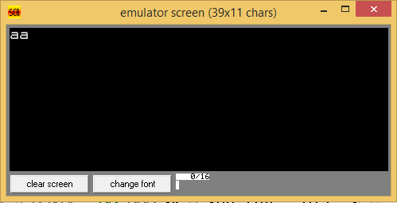

*Question Two:* Implement an assembly code to

* + take 2 single character input
  + Store them in 2 variables
  + Convert the uppercase one into Lowercase
  + Convert the Lowercase one into uppercase
  + Display them

*Code:*

org 100h

.model small

.data

str1 db 'Enter Lower Case: $'

str2 db 'Enter Upper Case: $'

str3 db 'Result: Lower Case to Upper Case: $'

str4 db ' Upper Case to Lower Case: $'

strx db ?

stry db ?

.code

main proc

lea dx, str1

mov ah, 09h

int 21h

mov ah, 01h

int 21h

sub al, 20h

mov strx, al

; new line

mov ah, 02h

mov dl, 0dh

int 21h

mov dl, 0ah

int 21h

lea dx, str2

mov ah, 09h

int 21h

mov ah, 01h

int 21h

add al, 20h

mov stry, al

; new line

mov ah, 02h

mov dl, 0dh

int 21h

mov dl, 0ah

int 21h

lea dx, str3

mov ah, 09h

int 21h

mov dl, strx

mov ah, 02h

int 21h

lea dx, str4

mov ah, 09h

int 21h

mov dl, stry

mov ah, 02h

int 21h

endp

end main

*Output:*

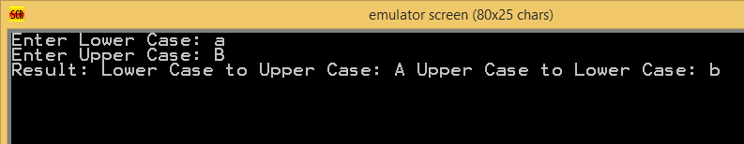

*Question Three:* Take an integer input from keyboard and print corresponding square of stars.

*Code:*

org 100h

.code

mov cx, 0

outerLoop:

cmp cx, 3

je done

mov bx, 1

innerLoop:

mov ax, cx

mov ah, 2

mov dl, '*'

int 21h

cmp bx, 3

je innerLoopDone

inc bx

jmp innerLoop

innerLoopDone:

mov ah, 02h

mov dl, 0dh

int 21h

mov dl, 0ah

int 21h

inc cx

jmp outerLoop

done:

ret

*Output:*

*Output:*

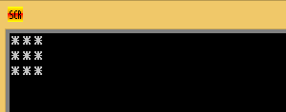

*Question Four:* Take an integer input from keyboard and print corresponding triangle of stars.

*Code:*

org 100h

mov bx,9

L1:

mov cx,bx

L2:

cmp cx,0

jz done

mov ah,2

mov dl,'*'

int 21h

LooP L2

dec bx

mov ah,02h

mov dl,0dh

int 21h

mov dl,0ah

int 21h

LooP L1

done:

ret

*Output:*

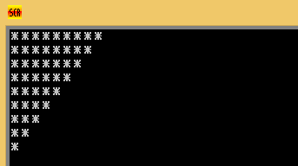

*Question Five:* Take an integer input from keyboard and print corresponding triangle of stars.

*Code:*

.CODE

main proc

MOV CX,3

MOV BX,1

loop1:

MOV CX, BX

loop2:

CMP CX, 0

JZ done

mov ah, 2

mov dl, '*'

int 21h

loop loop2

inc bx

cmp bx, 4

je done

mov ah, 02h

mov dl, 0dh

int 21h

mov dl, 0ah

int 21h

loop loop1

ENDP

done:

MOV AH,4CH

INT 21H

RET

*Output:*

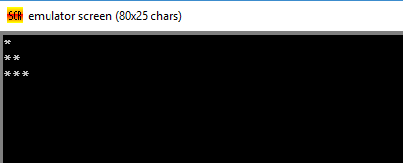

*Question Six:* Take an integer input from keyboard and print corresponding diamond of stars.

*Code:*

org 100h

.stack 100h

.data

i db ?

j db ?

k db ?

num db '1'

C1 db 1

input db ?

C2 db ?

.code

.startup

mov ah, 1

int 21h

mov j, al

mov input, al

mov ah, 2

mov dl, 0dh

int 21h

mov dl, 0ah

int 21h

L1:

mov bl, j

mov i, bl

cmp i, '1'

je L2

space_loop:

mov dl, ' '

mov ah, 2

int 21h

dec i

cmp i, '1'

jne space_loop

L2:

mov bl, C1

mov k, bl

NL:

mov al, '*'

mov bl, 2

div al

cmp al, 0

je ps

mov dl,'*'

mov ah, 2

int 21h

ps:

mov dl, ' '

mov ah, 2

int 21h

dec k

cmp k, 0

jg NL

add C1, 1

inc num

mov ah, 2

mov dl, 0dh

int 21h

mov dl, 0ah

int 21h

dec j

cmp j, '0'

jne L1

mov bl, input

mov j, bl

mov bl, 1

mov C1, bl

dec num

mov bl, input

sub bl, 30h

mov C2, bl

L3:

mov bl, C1

mov i, bl

space_loop2:

mov dl, ' '

mov ah, 2

int 21h

dec i

cmp i, 0

jne space_loop2

inc C1

mov bl,C2

mov k, bl

dec num

L4:

mov al, '*'

mov bl, 2

div al

cmp al, 0

je L5

mov ah, 2

mov dl, '*'

int 21h

L5:

mov ah, 2

mov dl, ' '

int 21h

dec k

cmp k, 1

jne L4

dec C2

mov ah, 2

mov dl, 0dh

int 21h

mov dl, 0ah

int 21h

dec j

cmp j, '1'

jne L3

mov ah, 2

mov dl, 0dh

int 21h

mov dl, 0ah

int 21h

.exit

ret

*Output:*

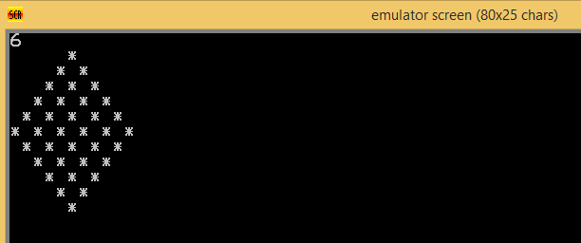

*Question Seven:* Take a character input from keyboard and print corresponding binary value and count the number of 1’s in that binary value (using loop and rotation operation)

*Code:*

.model small

.stack 100h

.code

main proc

mov bh,0

mov ah,1

int 21h

mov bl,al

mov cx,8

top:

rol bl,1

jc e

jnc e1

e:

mov ah,2

mov dl,49

int 21h

inc bh

jmp e2

e1:

mov ah,2

mov dl,48

int 21h

e2:

loop top

mov ah,2

mov dl,0ah

int 21h

mov dl,0dh

int 21h

add bh,48

mov ah,2

mov dl,bh

int 21h

main endp

end main

*Output:*

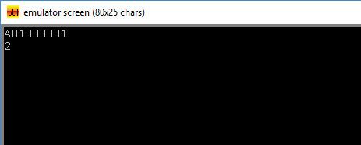

*Question Eight:* Write an assembly program to reverse a number of 10 digits. Also display an error message if the user is giving input anything except numbers (0-9).

*Code:*

include emu8086.inc

org 100h

.model small

.stack 100h

.data

data1 dw 0

v dw 0

cc db 0

pri db "Enter number: $"

outx db 0ah, 0dh, "Output: $"

.code

lea dx, pri

mov ah, 09h

int 21h

mov cx, 9

l1:

mov ah, 01h

int 21h

mov bx, ax

cmp bl, 30h

je ok

cmp bl, 31h

je ok

cmp bl, 32h

je ok

cmp bl, 33h

je ok

cmp bl, 34h

je ok

cmp bl, 35h

je ok

cmp bl, 36h

je ok

cmp bl, 37h

je ok

cmp bl, 38h

je ok

cmp bl, 39h

je ok

jnz nook

nook:

print "Error!"

cmp cl, 0

jz output

loop l1

ok:

push bx

cmp cl, 0

jz output

loop l1

output:

lea dx, outx

mov ah, 09h

int 21h

mov cx, 10

l2:

pop bx

mov ah, 02h

mov dl, bl

int 21h

dec cx

cmp cx, 0

jnz l2

end

*Output:*

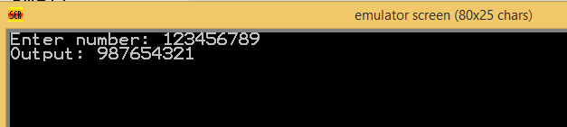

*Question Nine:* Write an assembly program to take a multi digit number (3 digit number) and display it.

*Code:*

include emu8086.inc

org 100h

.model small

.stack 100h

.data

data1 db 10

data2 dw 0

outx db 0ah, 0dh, "Output: $"

input db "Input: $"

.code

DEFINE_SCAN_NUM

DEFINE_PRINT_NUM

DEFINE_PRINT_NUM_UNS

mov cx, 0

mov bl, 00h

lea dx, input

mov ah, 09h

int 21h

l1:

mov ah, 1

int 21h

cmp al, 0dh

jz ter

mov ah, 0

mov data2, ax

sub data2, 30h

mov dx, data2

mov data2, bx

mov ax, data2

mul data1

mov bx, ax

add bx, dx

loop l1

ter:

lea dx, outx

mov ah, 09h

int 21h

mov ax, bx

call print_num

ret

end

*Output:*

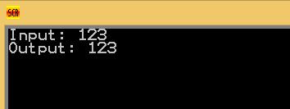

*Question Ten:* Take inputs from keyboard

* Print “Digit “ if it is Numeric value
* Print “Uppercase “if it is Uppercase Letter
* Print “Lowercase” if it is Lowercase Letter

*Code:*

org 100h

.model small

.stack 100h

.data

vari db 0

digit db "Digit$"

ucase db "Uppercase$"

lcase db "Lowercase$"

error db "Input is a not a digit nor uppercase nither lowercase.$"

str1 db "Enter something: $"

str2 db 0ah, 0dh, "Result: $"

.code

main proc

lea dx, str1

mov ah, 09h

int 21h

mov ah, 01

int 21h

mov vari, al

mov cl, 10

mov bl, 30h

l1:

cmp al, bl

jz show1

inc bl

loop l1

mov cl, 26

mov bl, 41h

l2:

cmp al, bl

jz show2

inc bl

loop l2

mov cl, 26

mov bl, 61h

l3:

cmp al, bl

jz show3

inc bl

loop l3

jnz show4

show1:

mov vari, al

lea dx, str2

mov ah, 09h

int 21h

lea dx, digit

mov ah, 09h

int 21h

ret

show2:

mov vari, al

lea dx, str2

mov ah, 09h

int 21h

lea dx, ucase

mov ah, 09h

int 21h

ret

show3:

mov vari, al

lea dx, str2

mov ah, 09h

int 21h

lea dx, lcase

mov ah, 09h

int 21h

ret

show4:

mov vari, al

lea dx, str2

mov ah, 09h

int 21h

lea dx, error

mov ah, 09h

int 21h

ret

endp

end main

*Output:*

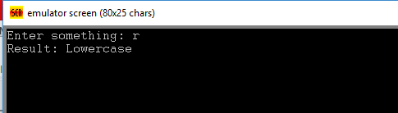

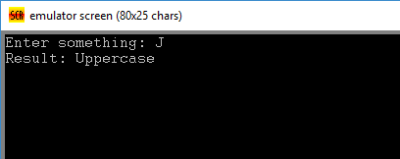

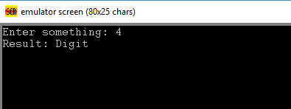

*Question Eleven:* Take an integer input from keyboard and print corresponding triangle of stars

*Code:*

.CODE

main proc

MOV CX,6

MOV BX,1

loop1:

MOV CX, BX

loop2:

CMP CX, 0

JZ done

mov ah, 2

mov dl, '*'

int 21h

loop loop2

inc bx

cmp bx, 7

je done

mov ah, 02h

mov dl, 0dh

int 21h

mov dl, 0ah

int 21h

loop loop1

ENDP

done:

MOV AH,4CH

INT 21H

RET

*Output:*

